In recent years, robotic cleaners have taken major attention in robotics research due to their effectiveness in assisting humans in floor cleaning applications at homes, hotels, restaurants, offices, hospitals, workshops, warehouses and universities etc.

Basically, robotic cleaners are distinguished on their cleaning expertise like floor mopping, dry vacuum cleaning etc. Some products are based on simple obstacle avoidance using infrared sensors while some utilize laser mapping technique. Each cleaning and operating mechanism of robotic floor cleaners has its own advantages and disadvantages. For example, robots utilizing laser mapping are relatively faster, less time consuming and energy efficient but costly, while obstacle avoidance based robots are relatively time consuming and less energy efficient due to random cleaning but less costly.

Countries like India are way back in manufacturing low cost robotic cleaners. Importing them from abroad increases their costs. The main objective of this work is to provide a substantial solution to the problem of manufacturing robotic cleaner utilizing local resources while keeping it low costs

**Working Principle :**

The majority of the vacuums have a motor with a fan. As the fan blades turn, they force air forward, toward the exhaust port. At the exhaust port it has a filter which prevents the dust particles being thrown away again.

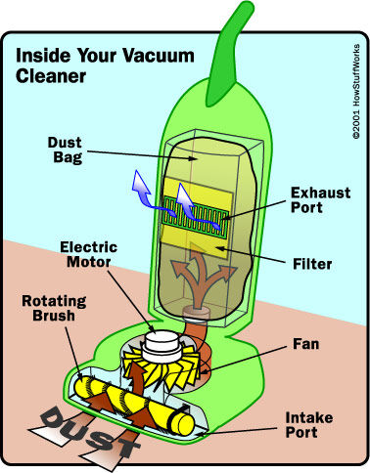

**How does a vacuum robot work?**

The principle is pretty similar but as you can see in the second picture, the fan motor is at the last step which means that the dust is not driven through it. The air that is being sucked is first filtered and then pushed toward the exhaust port.

The main difference between each of the vacuums is that the robot one has a microcontroller and sensors which let the robot make decisions so that it can vacuum your room autonomously. Most of the vacuum robots nowadays have really nice algorithms built-in, for instance, they can map your room so that they can plan a path and perform a faster cleaning. They also have other features like side brushes, collision detection, return to its charging base, etc.

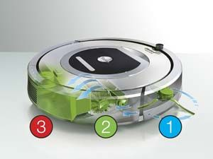

In this work, “smart cleaning robot ” has been designed for consumer/office environments and its each component in accordance with IEEE Standard. Proposed design is being operated in dual modes. In one of the modes, the robot is fully autonomous and making decisions on the basis of the outputs of infrared proximity sensors values being processed by Arduino (mega) controller and control the actuators (2 DC encoder motors) by the H-bridge driving circuitry. This robot can be controlled by the Android app connected thought the internet so make it IoT enable.